Blue = left

Orange = right

Sound 1:

1. 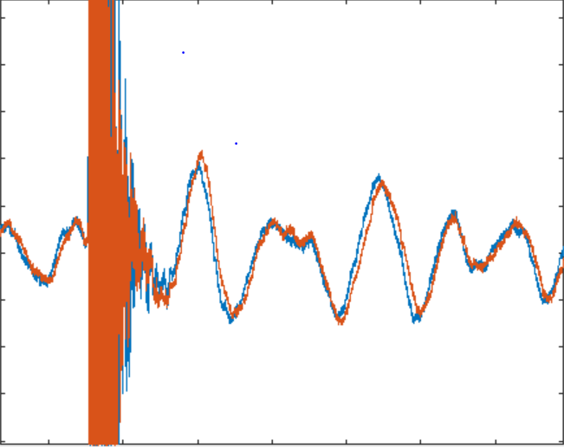

Yes, the graph shows the delayed response by the right ear to the left ear.

2. ITD = 0.2182 ms, close to expected 2.8 (45 degrees)

250 hz

3. IID results calculated: 8.0369, 3.6274, 5.1023, 17.6609

IID results expected: 0.1, 5, 8, 15

4. Lateral angle: -41.8103 degrees

Sound 2:

1. 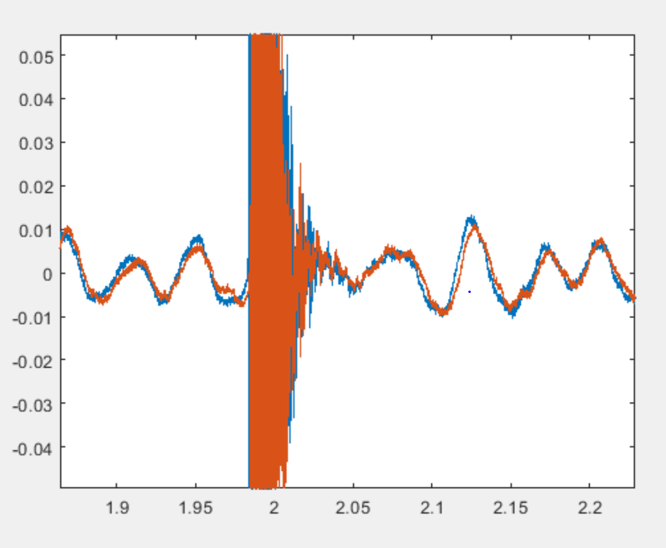

Yes, the graph shows proper delayed response from left to right ear.

2. ITD = 0.4266, kind of close to the expected 0.55

3. IID results calculated: 16.5512, 10.0154, 12.8704, 29.4304

IID results expected: 0.5, 5, 10, 20

4. Lateral angle: -68.95 degrees

Sound 3:

1. 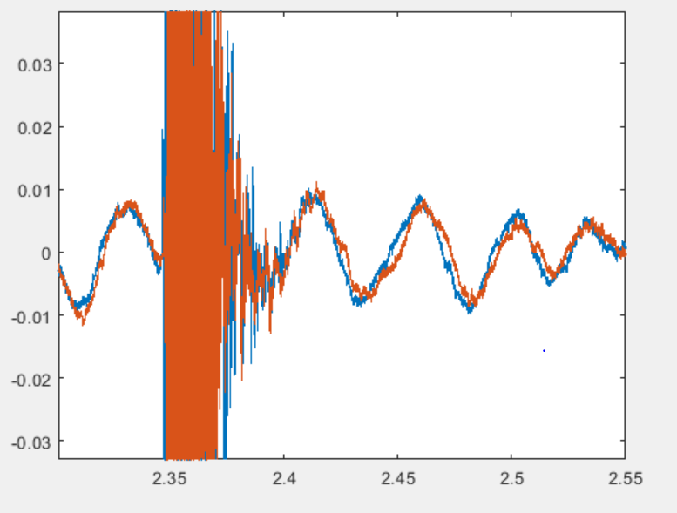

Yes, after listening to the audio, the graph represents an accurate delayed left to right response.

2. ITD = 0.4409, expected from graph 0.4

3. IID results calculated: 5.8589, 14.0189, -6.1526, 30.0388

IID results expected: 0.1, 5, 8, 15

4. Lateral angle: -90.0000

Sound 4:

1. 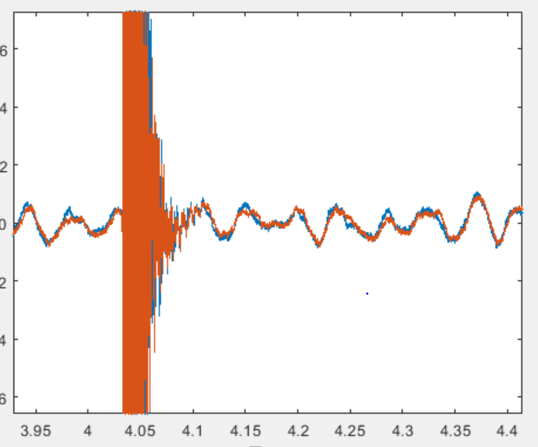

No, the graph was not what I expected to see. The sound appears to be going

from left to right interchangeably.

This may be caused by the angle of recording.

2. ITD = 0.4371, not close to expected 0.01

3. IID calculated: 16.5326, 3.0648, 2.9211, 6.2094

IID expected: 0, 0, 0, 0

4. Lateral angle: -3.826 degrees

Sound 5:

1. 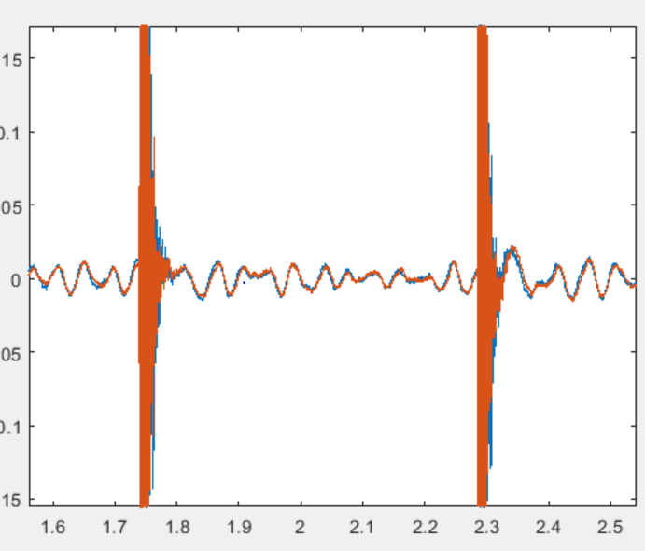

Yes, this graph is consistent with what was expected, with the sound delay

between the right and left sources.

2. ITD = 0.093, ITD was not close to the expected 0.4

3. IID calculated: 2.5923, 2.4111, 12.4058, 6.0090

IID expected: 0.1, 5, 8, 15

4. Lateral angle: 68.96 degrees

Sound 6:

1. 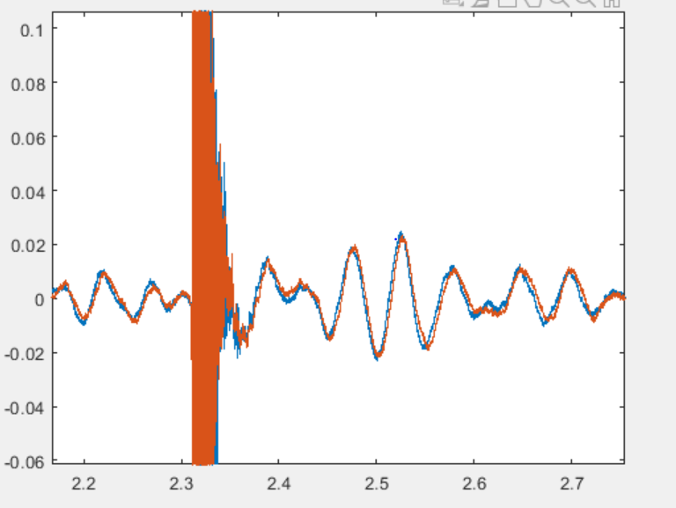

2. ITD = 0.39, ITD was not close to the expected 0.55

3. IID calculated: 3.0432, 3.8394, 7.7553, 6.0062

IID expected: 0.5, 5, 10, 20

4. Lateral angle: 19.74 degrees

Sound 7:

1. 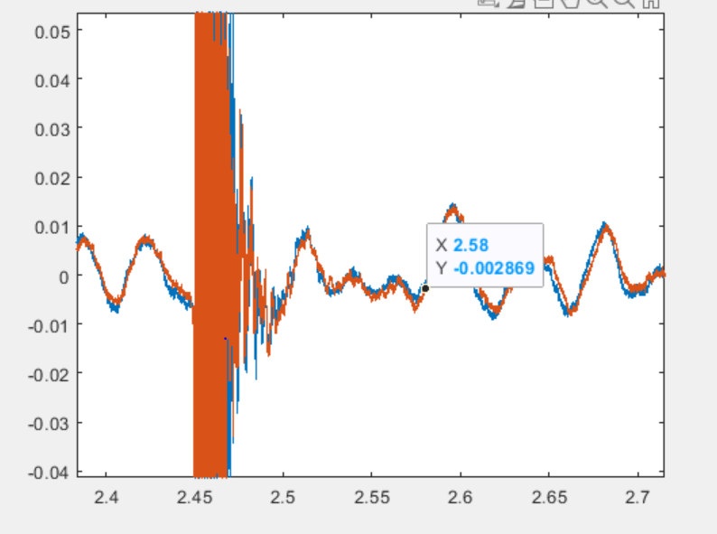

Yes, the signals appear to have the appropriate delay that was heard.

2. ITD: 0.5472, not close to the expected 0.28

3. IID calculated: 5.0187, 1.4948 , 9.7842, 16.3656

IID expected: 0.1, 5, 8, 15

4. Lateral angle: 23.5782 degrees

Sound 8:

1. 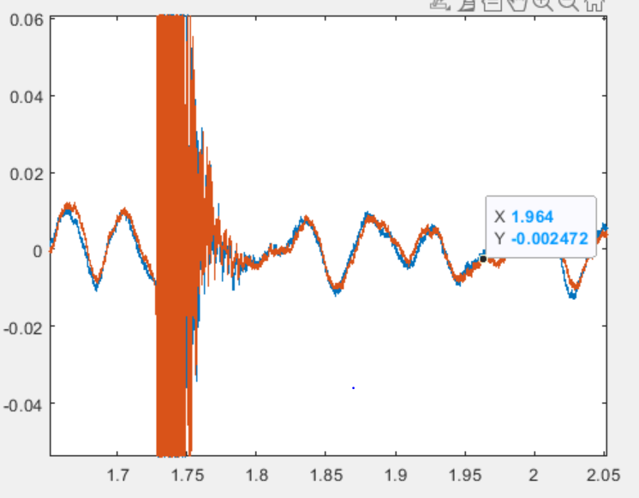

Yes, the audio is represented accurately by the plot.

2. ITD = 0.335, not close to expected 0

3. IID calculated: 6.4758, -17.5318, -0.0180, 11.0190

IID expected: 0, 0, 0, 0

4. Lateral angle: -11.5370 degrees

| Sound | Side of head inferred from calculations/  graph | Side of head recorded | ITD Calculated | ITD Expected from Graph |
| --- | --- | --- | --- | --- |
| Sound 1 | left | left | 0.2182 | 0.28 |
| Sound 2 | left | left | 0.4266 | 0.55 |
| Sound 3 | left | left | 0.4409 | 0.4 |
| Sound 4 | left | left | 0.471 | 0.01 |
| Sound 5 | right | right | 0.093 | 0.4 |
| Sound 6 | right | right | 0.39 | 0.55 |
| Sound 7 | right | right | 0.5742 | 0.28 |
| Sound 8 | right | left | 0.3335 | 0 |